BRACT’s
Vishwakarma Institute of Technology, Pune
Practical Implementation Sheet
Department: CSE-AI Semester: 5 Academic Year: 2026-27
Division: E Batch: 1 Practical No: 5
Roll no: 42 PRN No: 12414728 Name of Student: Saachi Laturiya
Subject Name : Deep Learning

Problem Statement : Implement and compare RNN, LSTM, and GRU models for sequence classification and analyze their performance using appropriate evaluation metrics.
Algorithm :
- Import the required libraries for deep learning, data preprocessing, and evaluation.
- Load the IMDB movie reviews dataset for binary sentiment classification.
- Preprocess the reviews by limiting the vocabulary and padding sequences to a fixed length.
- Build RNN, LSTM, and GRU models using an embedding layer, a recurrent layer, and a sigmoid output layer.
- Compile each model using the Adam optimizer and binary cross-entropy loss.
- Train each model on the training dataset for 3 epochs.
- Predict sentiment labels for the test dataset.
- Calculate accuracy, precision, recall, F1-score, and training time for each model.
- Compare the models using a performance table and graphs.
Code :
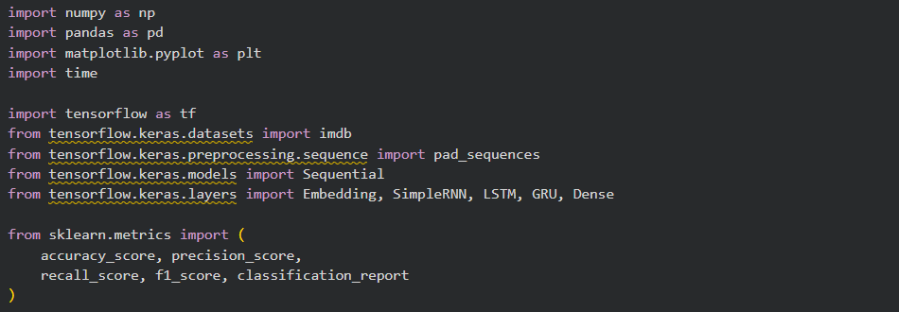
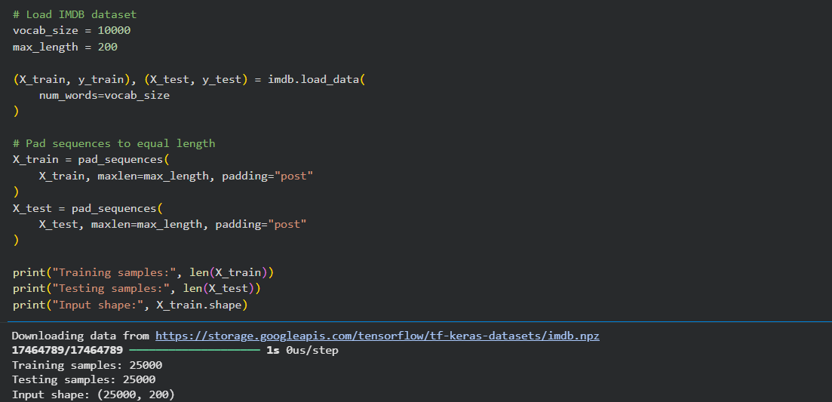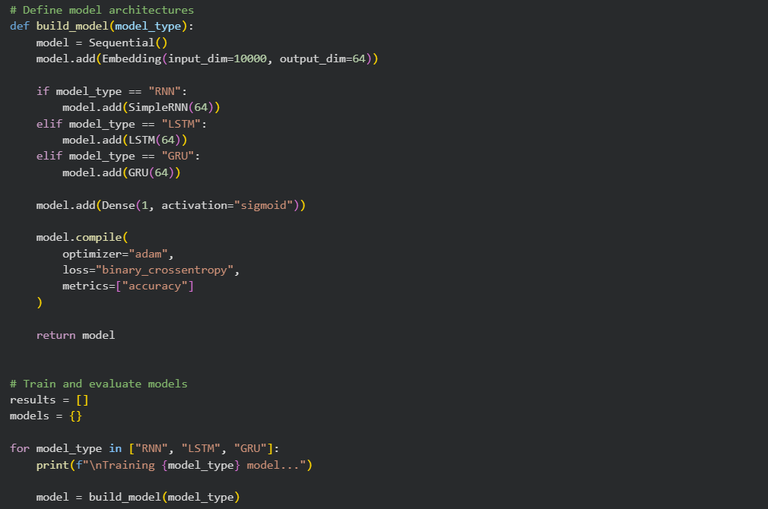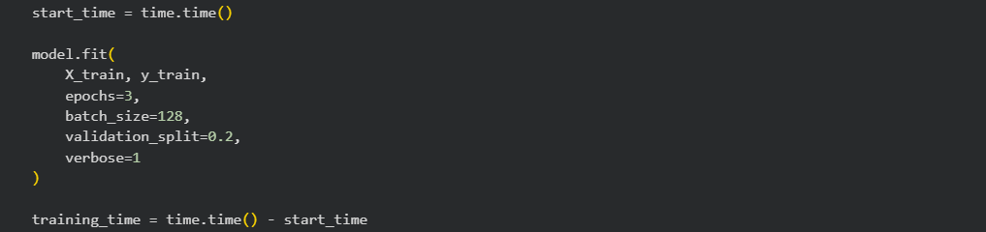
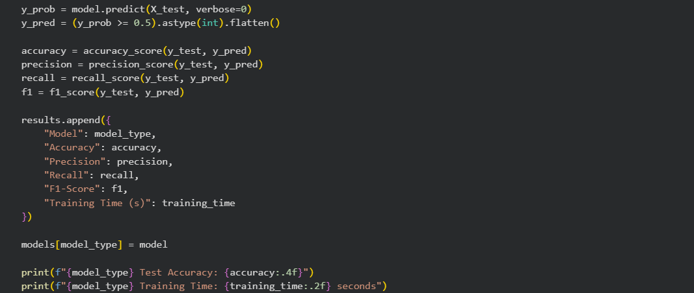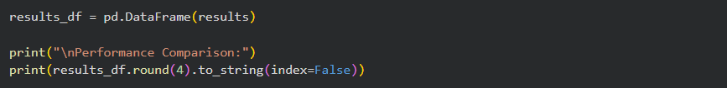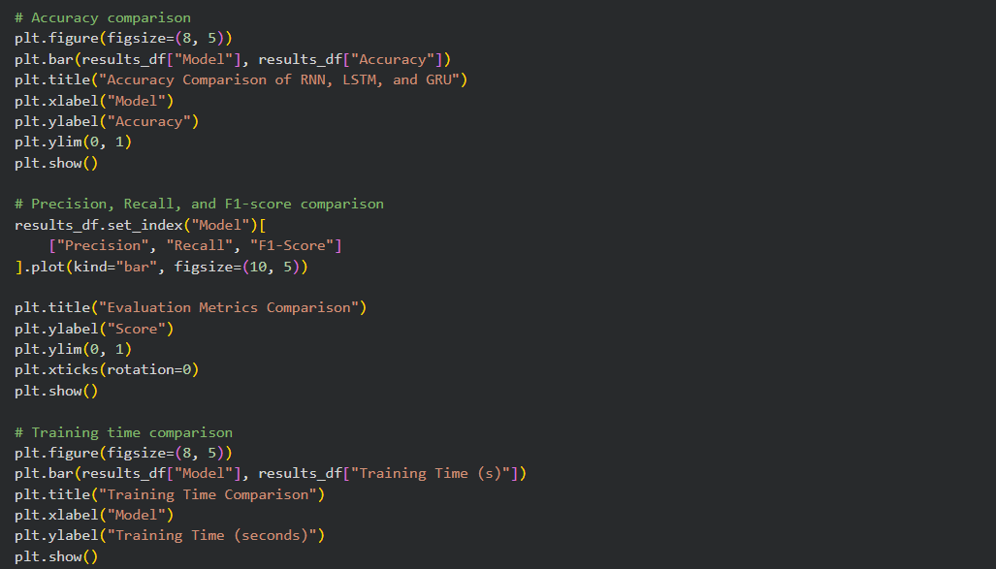

Output :
Figure 1: Training Performance and Test Accuracy of RNN, LSTM, and GRU Models
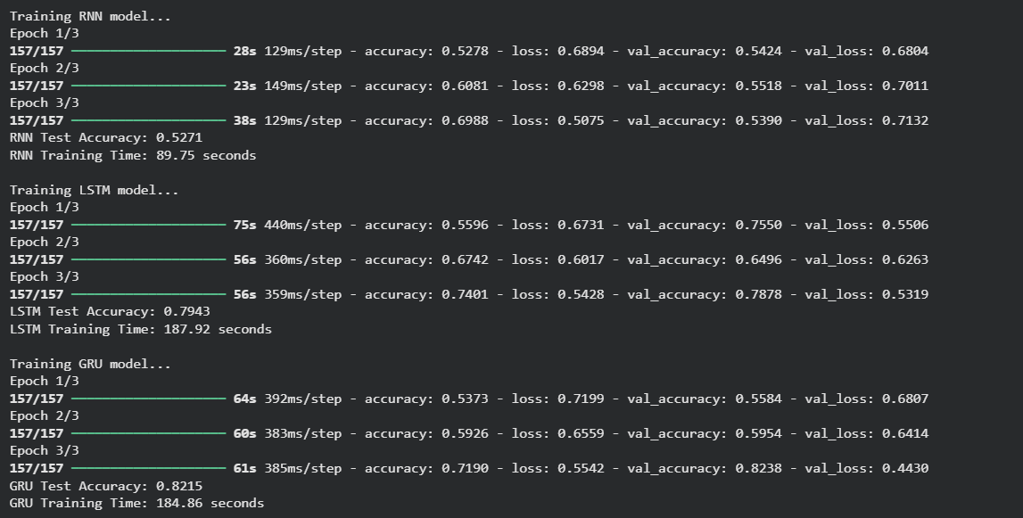
Figure 2: Accuracy Comparison of RNN, LSTM, and GRU
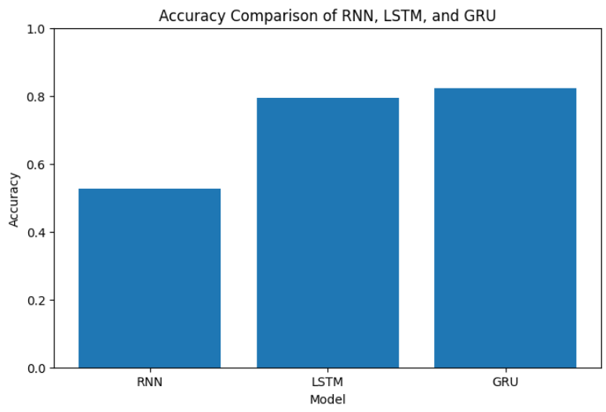

Figure 3: Evaluation Metrics Comparison
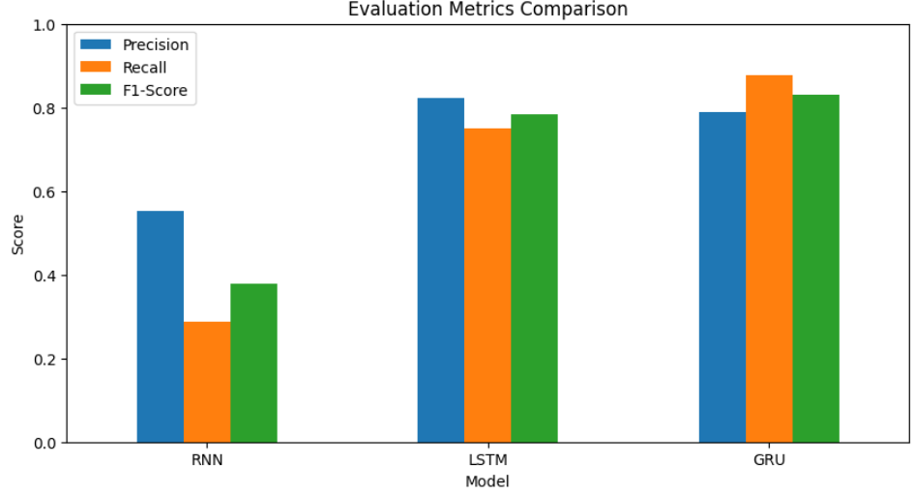Figure 4: Training Time Comparison
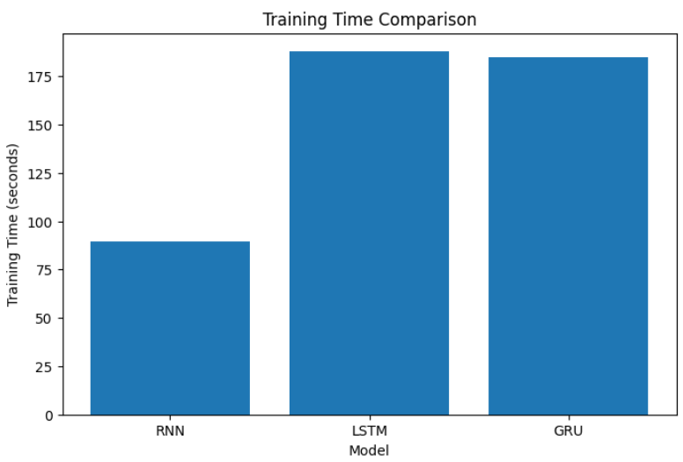

Table 1: Performance Comparison of RNN, LSTM, and GRU
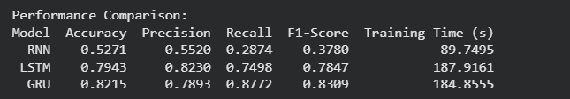
Conclusion :
The RNN, LSTM, and GRU models were implemented for binary sentiment classification using the IMDB movie reviews dataset. Their performance was evaluated using accuracy, precision, recall, F1-score, and training time. The comparison demonstrates the differences in classification performance and computational cost among the three recurrent neural network architectures.

